OVERVIEW
Both Two Pointers and Sliding Window are array/string traversal techniques that improve efficiency (usually from O(n²) → O(n)).
They are widely used in interview problems, competitive programming, and algorithm design.

PART 1: TWO POINTERS TECHNIQUE
Concept
The two-pointer technique uses two indices (often i and j or left and right) to traverse a list or string from different directions or at different speeds to achieve a goal.
Used when:
- The data is sorted or can be traversed sequentially
- You need to find pairs or subarrays with specific conditions

Common Patterns
- Opposite Direction → left from start, right from end Example: Sum problems in sorted array
- Same Direction → fast and slow pointers
Example: Detect cycle in linked list, remove duplicates

Example 1: Pair Sum in Sorted Array Problem:
Given a sorted array, find if there exists a pair with a given sum. arr = {1, 2, 4, 4, 7, 8, 11, 12} target
= 8

Brute Force Code:
public class BruteForce { public static void main(String[] args) { int[] arr = {1, 2, 4, 4, 7, 8, 11, 12}; int target = 8; hasPairWithSumBruteForce(arr,
target);
}
public static boolean hasPairWithSumBruteForce(int[] arr, int target) { int n = arr.length; for (int i = 0; i < n; i++) { for (int j = i + 1; j < n; j++) { if (arr[i]
+ arr[j] == target) {
System.out.println("Pair Found: (" + arr[i] + ", " + arr[j] + ")"); return true;
}
}
}
System.out.println("No Pair Found"); return
false;
}
}

Two Pointers Approach:
public class TwoPointers { public static void main(String[] args) { int[] arr = {1, 2, 4, 4, 7, 8, 11, 12}; int target = 8; hasPairWithSum(arr, target);
}
public static boolean hasPairWithSum(int[] arr, int target) { int left = 0; int right = arr.length - 1; while (left <
right) { int sum = arr[left] + arr[right]; if (sum == target) {
System.out.println("Pair Found: (" + arr[left] + ", " + arr[right] + ")"); return true;
} else if (sum < target) { left++;
}
else { right--;
}
}
System.out.println("No Pair Found"); return
false;
}
}
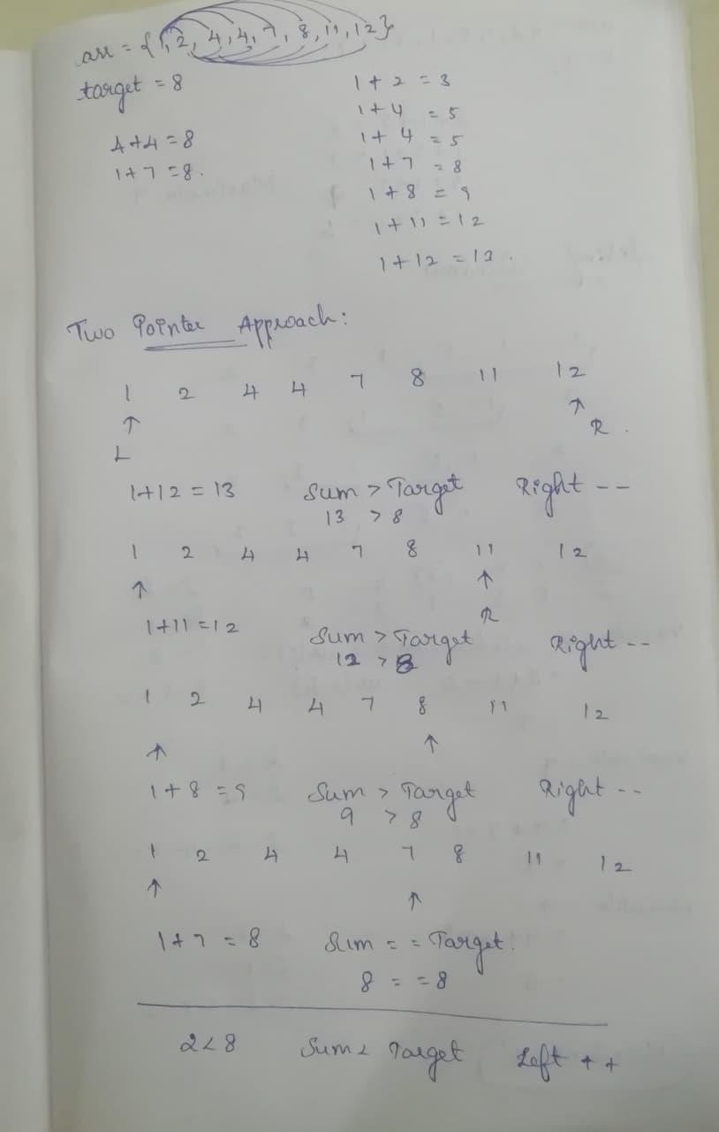

Explanation:
- Start with smallest and largest elements.
- If sum < target → move left pointer (need larger sum)
- If sum > target → move right pointer (need smaller sum)
Time complexity: O(n)
Space complexity: O(1)

Example 2: Remove Duplicates from Sorted Array public class RemoveDuplicates { public static int removeDuplicates(int[] nums) {
int i = 0; for (int j = 1; j < nums.length; j++) { if (nums[i] != nums[j]) {
i++; nums[i] = nums[j];
}
}
return i + 1;
}

public static void main(String[] args) { int[] arr = {1,1,2,2,3}; int len = removeDuplicates(arr);
System.out.println(len); // Output: 3
}
}
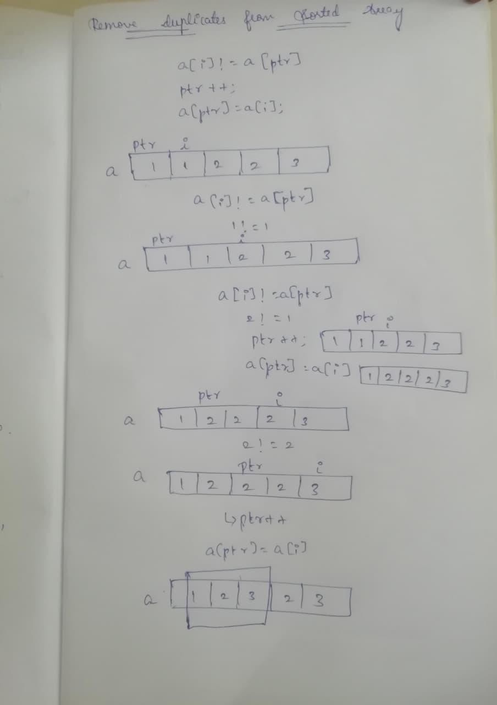

PART 2: SLIDING WINDOW TECHNIQUE
Concept
A sliding window is a contiguous subset of elements that “slides” over the array/string.
Used when:
- You need to find or optimize something in subarrays/substrings
- Usually applied for contiguous problems (like sum, max, count) 1.Find maximum sum of subarray of size k
arr = {2, 1, 5, 1, 3, 2}; k
= 3;

Brute Force Approach:
public class Cases { public static void main(String[] args) { int[] arr = {2, 1, 5, 1, 3, 2}; int k = 3;
System.out.println("Maximum sum of subarray of size " + k + " is " + maxSum(arr, k));
}
public static int maxSum(int[] arr, int k) { int n = arr.length; int maxSum = Integer.MIN_VALUE;
for (int i = 0; i <= n - k; i++) { int currentSum = 0;
for (int j = i; j < i + k; j++) {
currentSum += arr[j];
}
maxSum = Math.max(maxSum, currentSum);
}
return maxSum;
}
}

Sliding Window Technique:

public class Main { public static void main(String[] args) { int[] arr = {2, 1, 5, 1, 3, 2}; int k = 3;
System.out.println("Maximum sum of subarray of size " + k + " is " + maxSum(arr, k));
}
public static int maxSum(int[] arr, int k) { int n = arr.length; int maxSum = 0; int windowSum = 0;
for (int i = 0; i < k; i++) {
windowSum += arr[i];
}
maxSum = windowSum;
for (int i = k; i < n; i++) { windowSum += arr[i] - arr[i - k];
maxSum = Math.max(maxSum, windowSum);
}
return maxSum;
}
}
Time complexity: O(n)
